**Week 5 Progress Report: Proof of Purchase**

**Name: Rafil Yashooa**

**Data: Oct/3rd/2016**

**Section: A**

**Student #: N01040349**

Individual Progress Report

Week 5, all parts are acquired including web cam camera, raspberry pi kit and also the barcode strips. As for the barcode strips, I will be printing out more barcode strip from a regular printer if I need more samples for testing, debugging or trying out new ways for getting it to recognize the readings by the camera.

As of today’s class, I will be doing the research for my project, finding out how to get a webcam camera to recognize a bar code and write it to the terminal and so on.

The parts that I purchased are listed below. The raspberry pI was about $112 which came with a full kit. The kit included a preprogrammed SD card, HDMI cable, start kit manual and a case along with the unit itself. As for the webcam camera, I purchased it from a thrift store for about $10.

The barcode strips were actually done from an online generator at [https://www.barcodesinc.com/generator/index.php](https://www.barcodesinc.com/generator/index.php%20) I labeled each barcode and printed a couple of samples which I will be using for testing.

The student number barcodes always start with an ‘N’ followed by 8 digits, this is used for identifying the number so no wrong input is accepted when implementing the data in to the database server.

And the part number barcodes start with a ‘P’ as the identification number followed by 8 generated digits. This is also implemented to prevent wrong data to be stored.

Proof of purchase:

**Raspberry pI kit:**

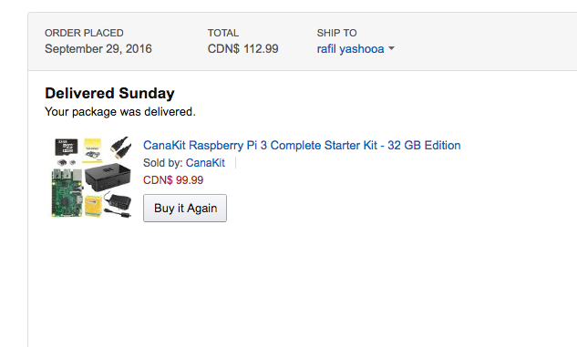

**Webcam:**

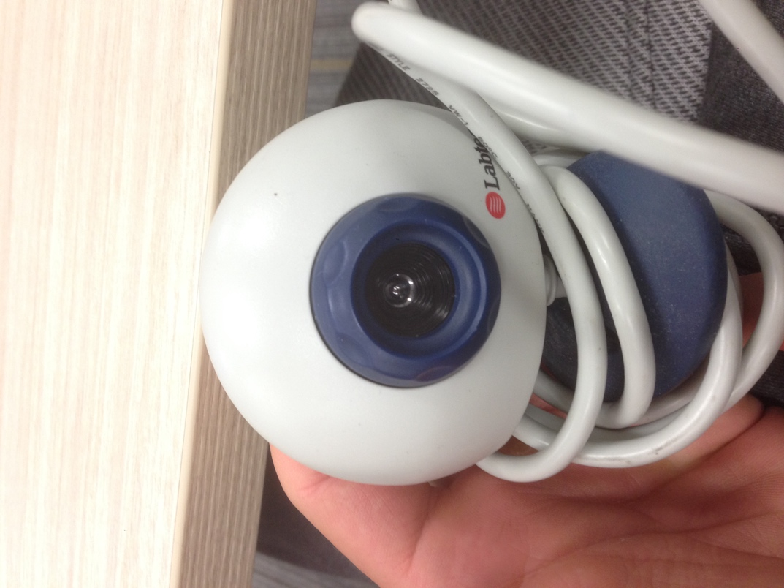

**Barcode Strips:**

**Part number strip Student number strip**

**/Users/RAF/Desktop/Screen Shot 2016-10-04 at 10.10.12 AM.png/Users/RAF/Desktop/Screen Shot 2016-10-04 at 10.09.55 AM.png**